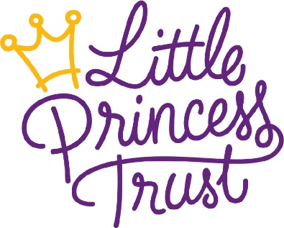
A personal message from our CEO:

Out of lockdown and on the road to recovery

July 23, 2020

Dear supporters, partners and friends.

I hope you are well as we take our first tentative steps forward out of lockdown?
I am writing with what is hopefully my final update as we start to settle in to our ‘new normal’. It has been a turbulent time for most, both personally and professionally. But we at The Little Princess Trust are confident that by focussing on our core beliefs we will be stronger and more united than ever before as normality is gradually restored.

Normal service levels are being resumed
The last few weeks have seen some incredibly positive steps for The Little Princess Trust in our transition out of lockdown and firmly on our road to recovery. I have enjoyed being back in the office as part of a phased return and look forward to welcoming back the rest of the team at the end of the month.
As workloads have increased due to a surge in activity, we have also been able to welcome back some of our volunteers. We are incredibly grateful for our committed volunteers who give their time so generously to the charity.
Like most charities we have been affected significantly with a decline in income. However, I am pleased to report that things are continuing to improve each month, giving us great hope for the future. The re-opening of hair salons on ‘trim-dependence day’ was a great milestone as we saw hair donations increase and a renewed enthusiasm as record number of online fundraising pages began to open.
We continue to focus on maintaining our key frontline service of providing wigs to children suffering hair loss due to cancer treatments and other conditions. Wig recipients and employee safety has been a priority throughout this period as has great levels of communication. During these times of stress and uncertainty we have focussed on delivery of the best service we could under the conditions.
As we move out of lockdown, all our normal service levels will be resumed. We will phase from virtual wig fittings to re-engaging with our wonderful partner salons over the coming weeks. So that face-to-face fittings will once again be available where appropriate.
We have also been inviting applications for research grants throughout the lockdown period and are looking forward to awarding funding to worthy projects, enabling them to continue their vital work of finding better treatments and cures for childhood cancers.

What have we learned?
As we consider the ‘new normal’, I hope that we do not forget some elements of the world we lived in pre-covid which, at times, could feel dysfunctional and that we genuinely apply some of the lessons we have learned over the last four months.
Let us hope that we can be kinder to each other, that we can treasure our healthcare system and that children’s paediatric cancer research gets the support and funding it so desperately needs.
Hopefully, we can continue to show neighbourly values and ensure that we are genuinely inclusive and non-discriminatory in all that we do. We can be mindful of our communities and demonstrate good activity in valuing our environment and take time to respect and value one another.
My ongoing commitment is that we continue to be as helpful as we can be to you - our paediatric cancer research community, our wig recipients, our salons, supporters, partners and friends.

Thank you!
I must commend all the staff at The Little Princess Trust for their astonishing commitment, versatility, helpfulness and general attitude throughout this period. They have collectively ensured we have continued to operate and achieve our goals without interruption.
We are continually inspired by the courage of our wig recipients and the commitment and expertise of our funded researchers. This is what drives us to keep doing more to continue giving Hair and Hope to children and young people with cancer.
We are humbled by the support of our hair donors and forever indebted to the financial assistance of our fundraisers and corporate partners. Not to mention those who simply know us and talk about us and, in turn, generate our next supporter.
For any questions, please do not hesitate to contact myself directly.
Best wishes

Phil Brace
The Little Princess Trust Chief Executive

